Experiment-4

**Aim:** To create a docker image via Dockerfile, upload it on docker hub and pull it on some other system.

**Now follow the steps under neath.**

**Step1:** Create a Dockerfile and write the layers you want to implement/customize for your docker image.

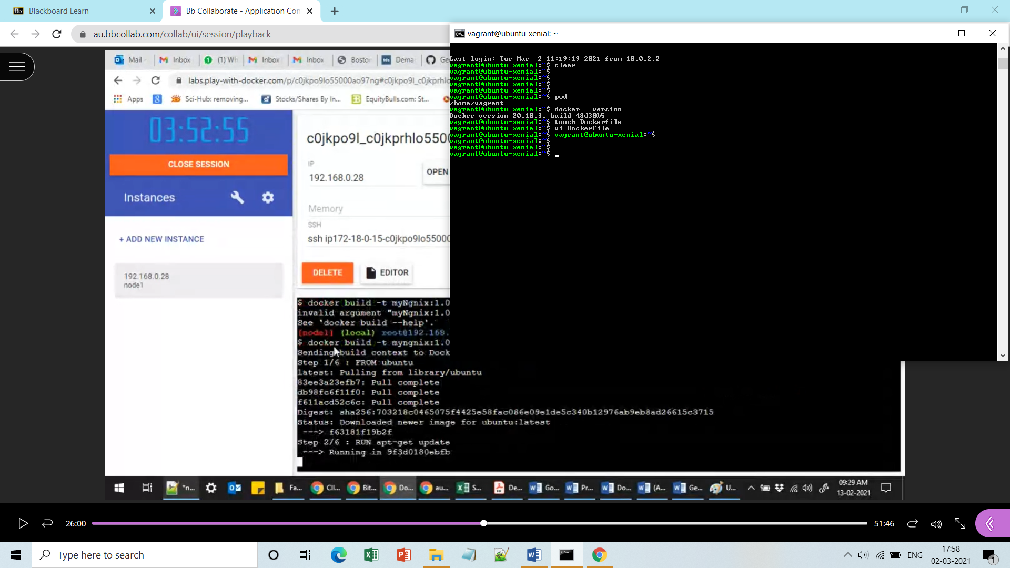

**Content of your docker file:**

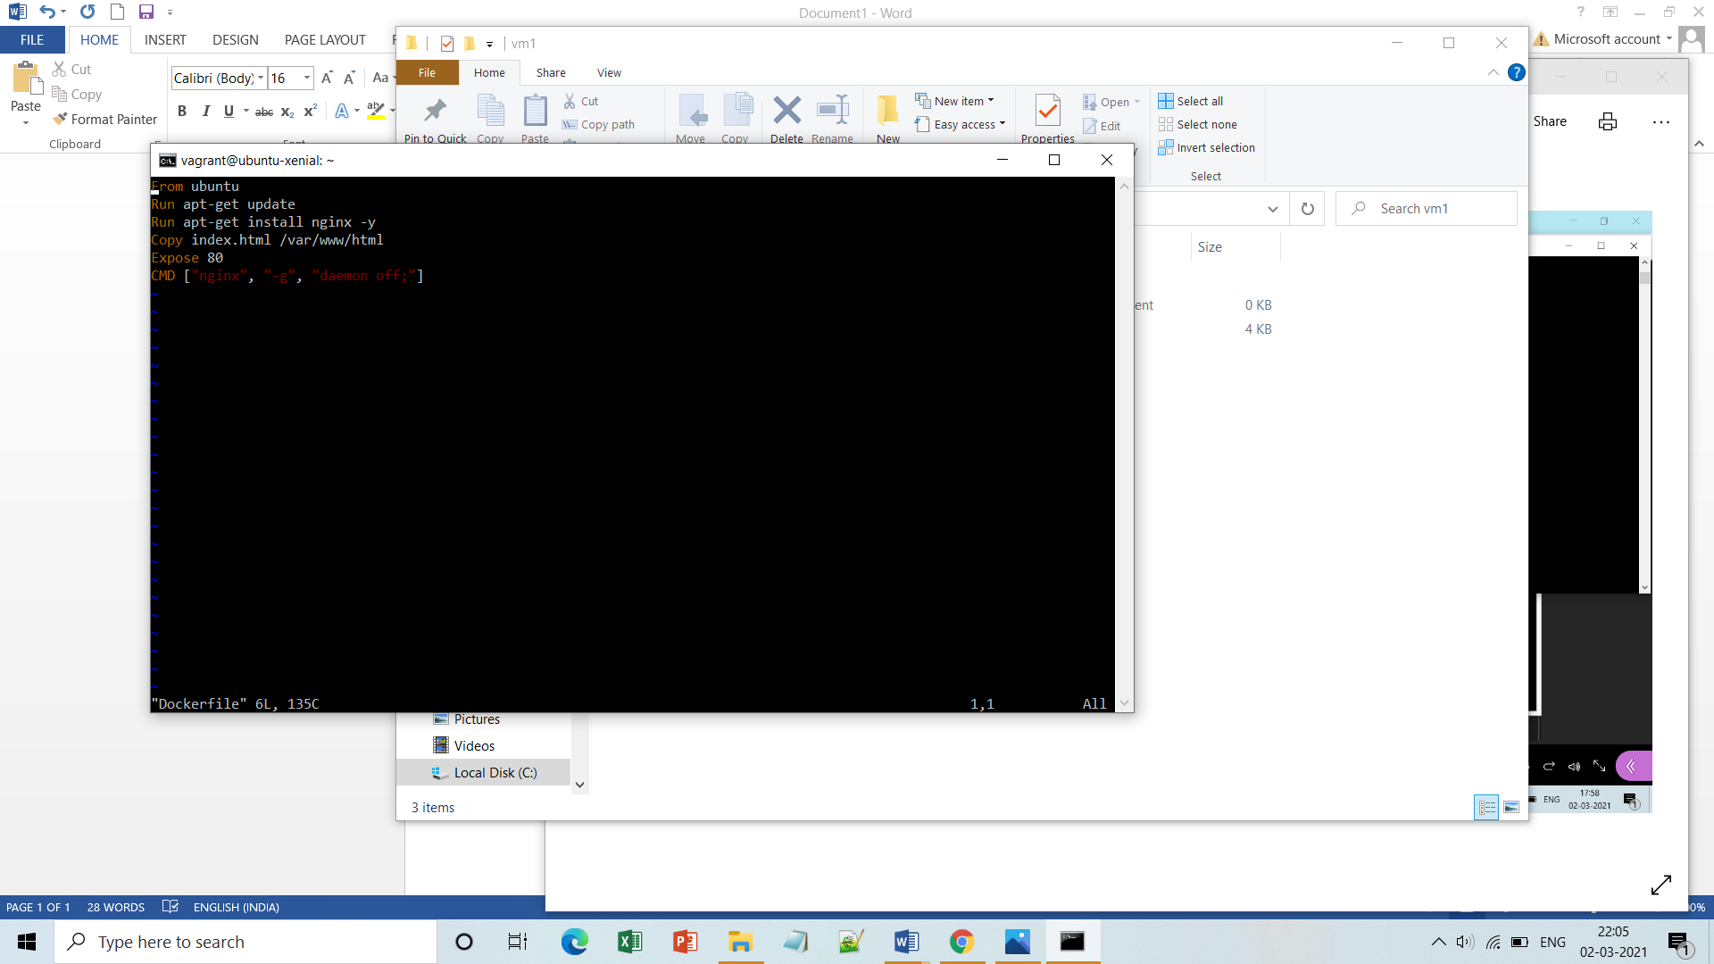

**Note:-** You can always add extra layers of your needs.

**Step2:**Make an index.htlm file in the same directory where your Dockerfile is there.

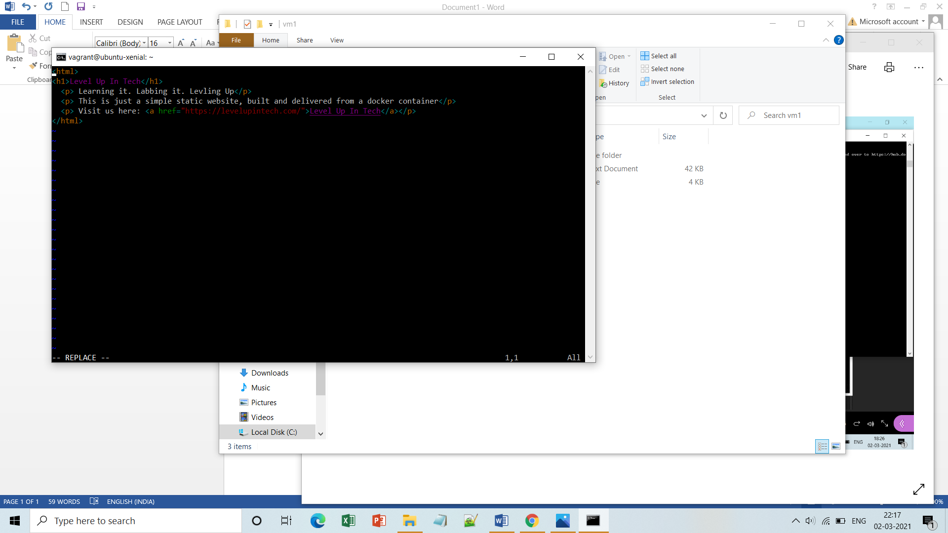

**Step3:** Now build your docker image with same tag as your docker-hub repo name or give any tag to your image, repo of same name will be created in dockerhub acc. 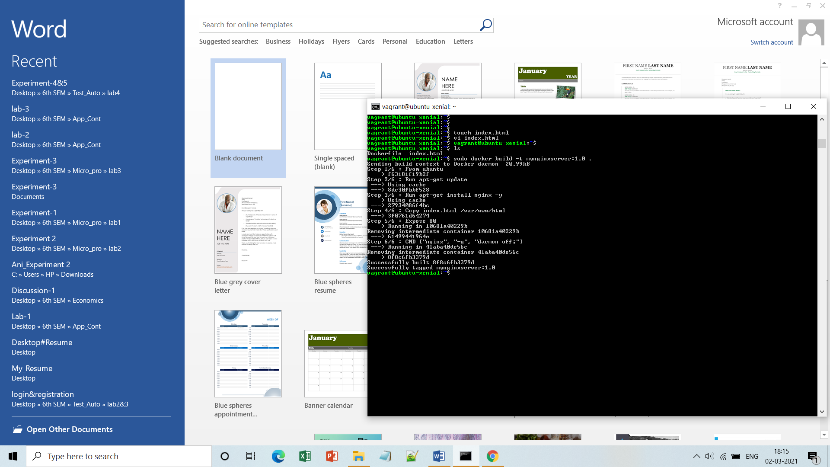

ffff

**Step4:** Check whether image has been created and working fine or not(by running it).

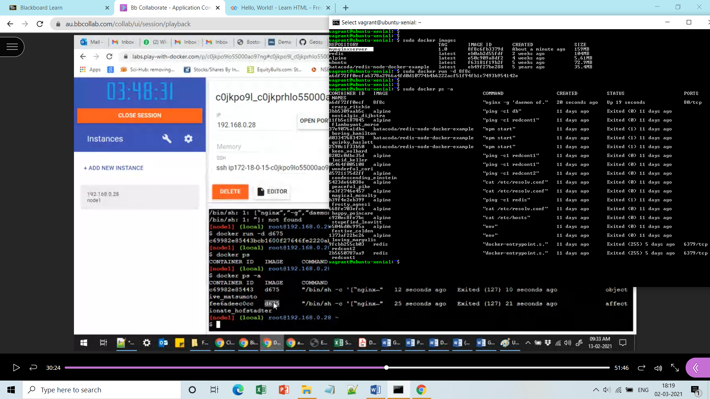

**Step5:** Login to your docker-hub acc via user-id and password.

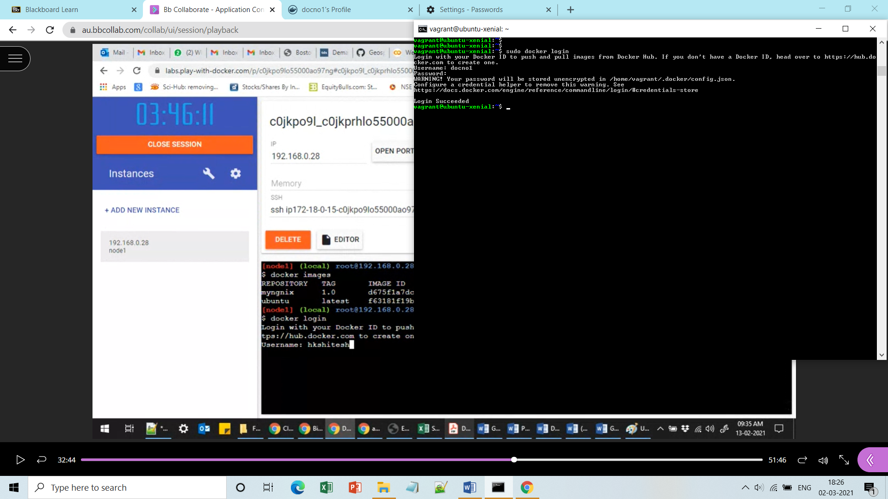

**Step6:** Set the tag of the image same as your complete repo name.

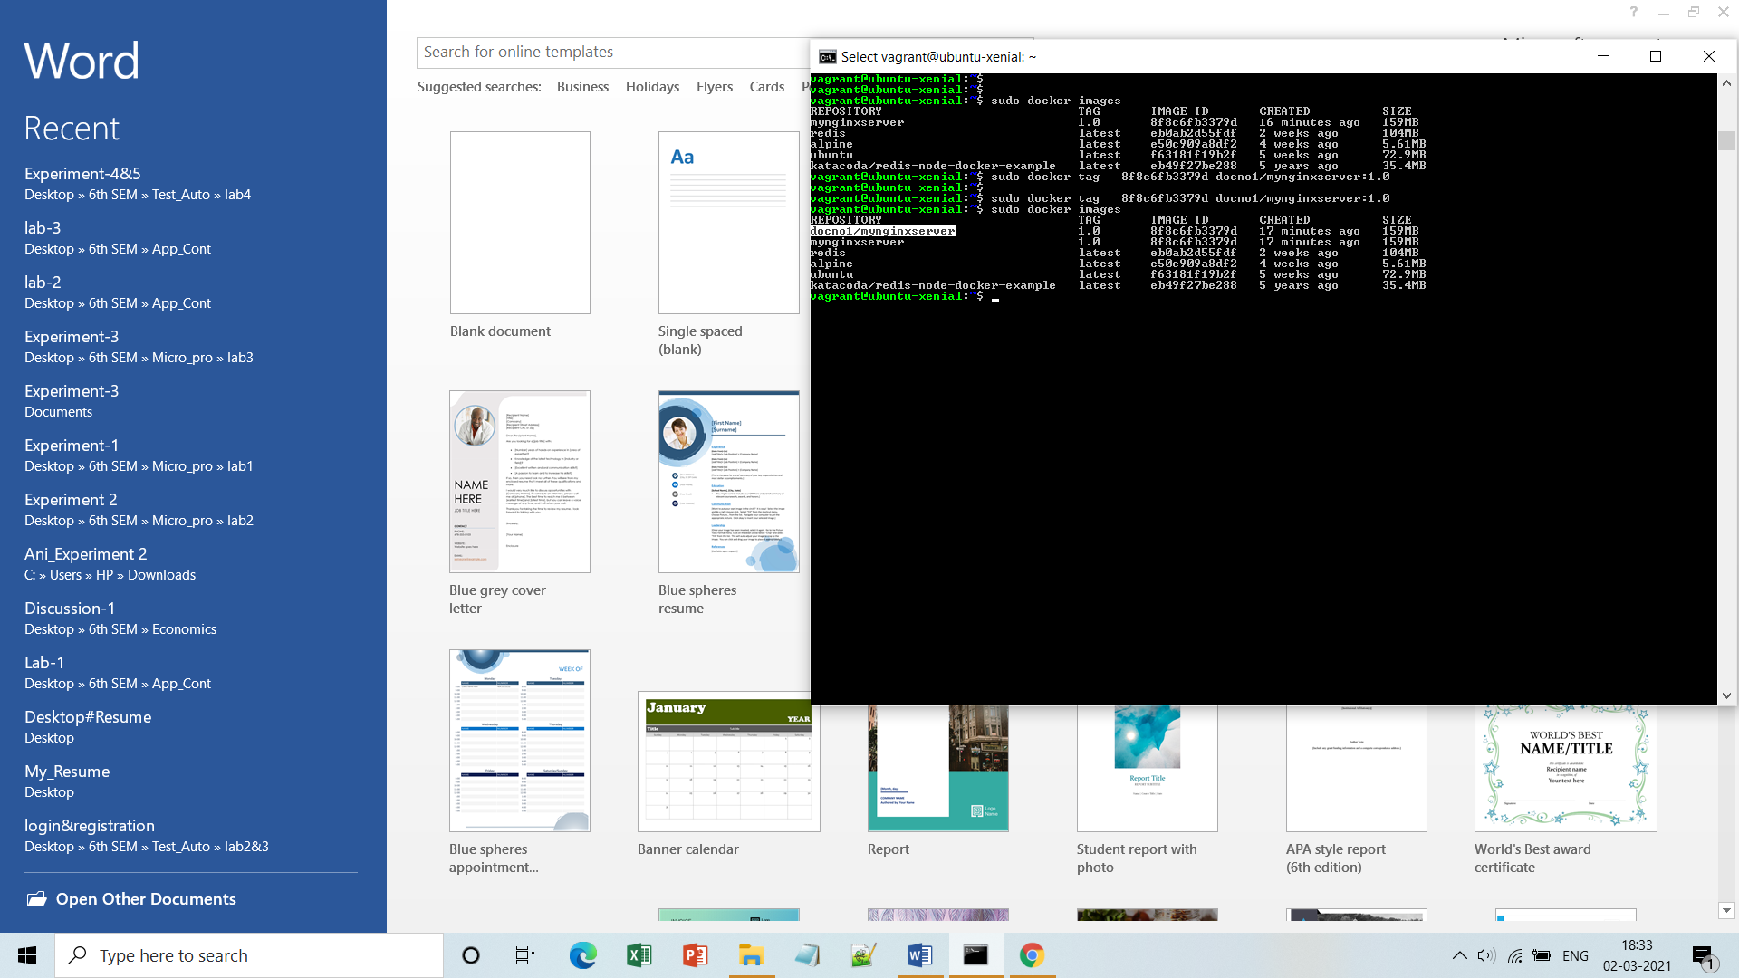

**Step7:** Now push your created image to the docker hub, in your created repo.

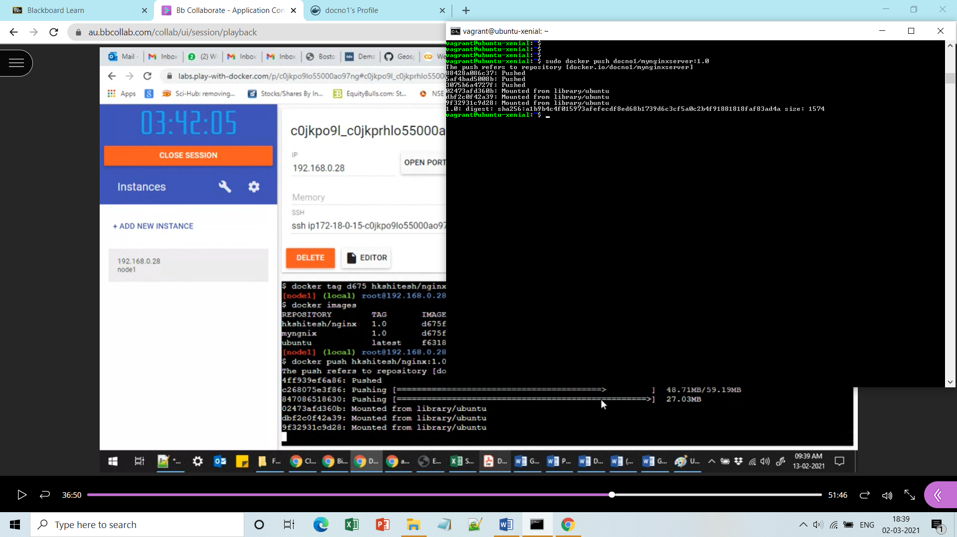

**Step8:** Here you should find your image uploaded: 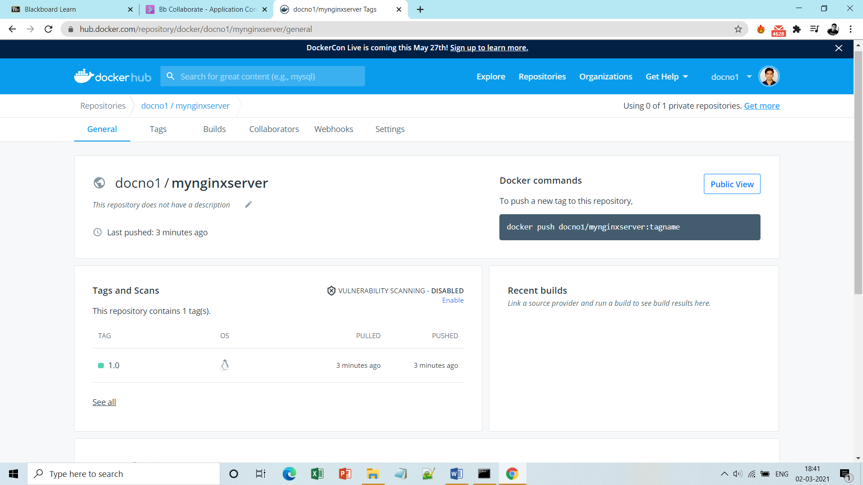

**Step9:** You can copy the shaded command to pull this image on your system as well.

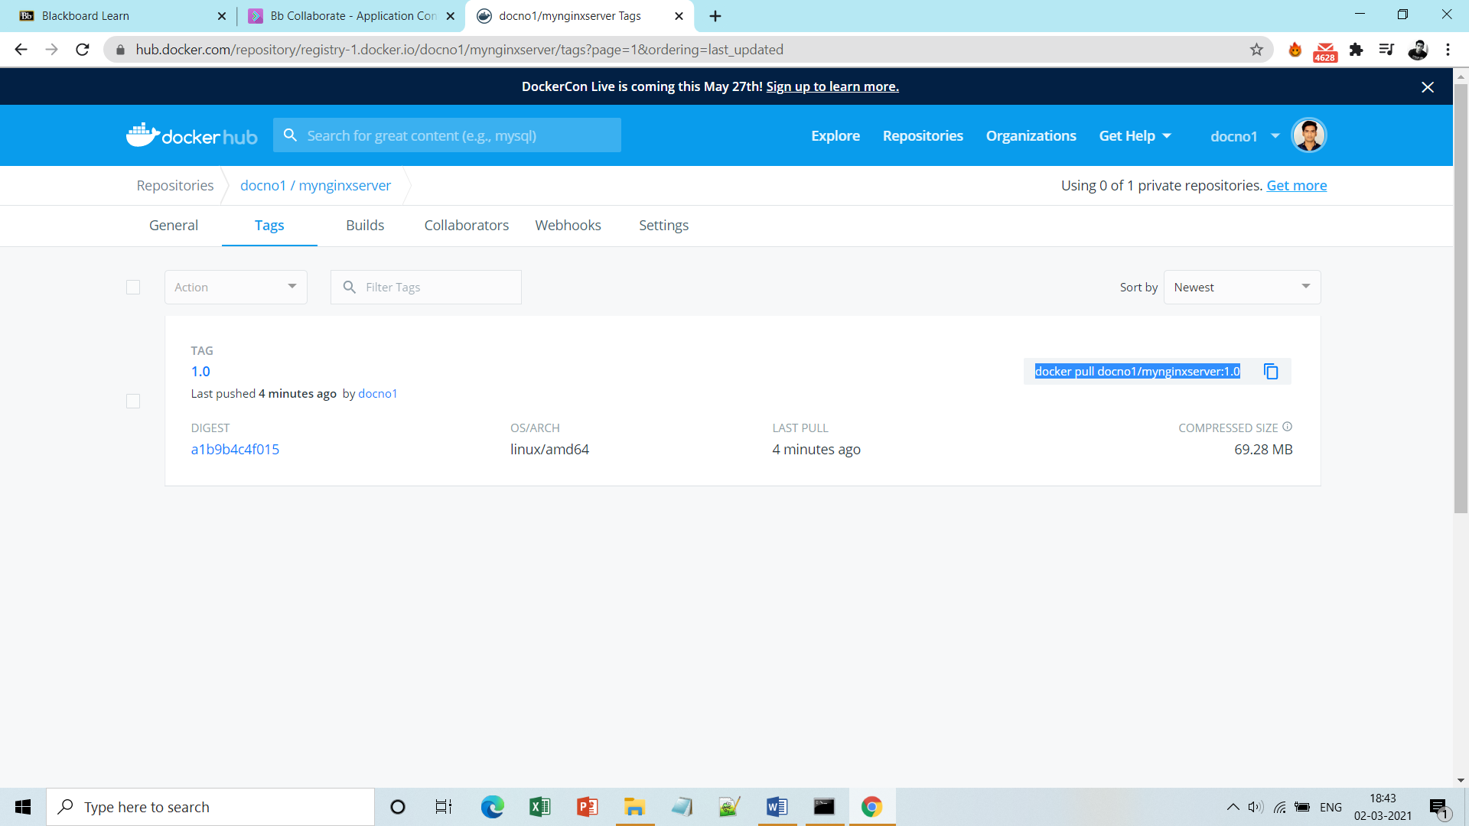

**Step10:** Once you run it in the background and map the port that you have exposed while creating image with the port that you use on your localhost, it automatically will be pulled and downloaded in your system:

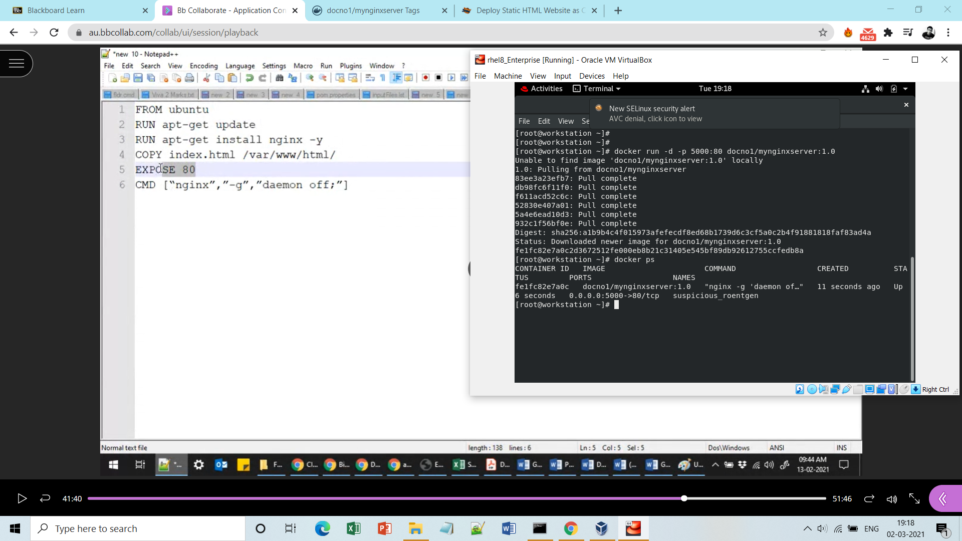

**Step11:** Now go the browser and type localhost:5000/your port-choice and see the result:

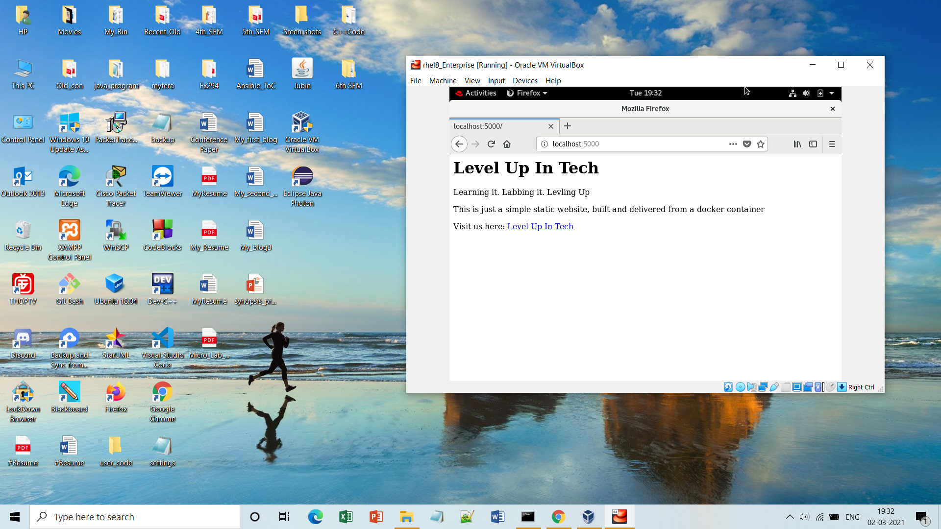

**Done!!**